**Fruit Voting Application**

* Introduction:

This online application helps school’s cafeteria to provide a healthier snacking options for its students. Students can register on this application and then they can login to vote for their favorite fruit. They can also add their favorite fruit if it is not present in the list.

They can view their own voting history and after casting the vote, they will see overall voting result.

* Technology used:

1. Angular 2
2. HTML, CSS, Bootstrap
3. PHP REST API
4. MySQL Database

* Development Tools used:

1. Visual Studio Code
2. XAMPP
3. Mozilla Firefox Browser

* Building this project:
  + Get the angular project files from my github repository (<https://github.com/mayurbabar/Fruit-Voting>).
  + Get the XAMPP server from <https://www.apachefriends.org/index.html> .
  + Get NodeJS from <https://nodejs.org/en/download/>.
  + Install the dependencies by npm install
  + Install Angular CLI by running below command in cmd.

npm install @angular/cli

* + Open the XAMPP application and start Apache and MySQl server.
  + Open Phpmyadmin (<http://localhost/phpmyadmin/index.php>) create database by running “CREATE DATABASE fruitvoting;” query and then run the “fruitvoting.sql” file. It will create and load the required tables.
  + Place the ‘restapi’ folder in ‘C:\xampp\htdocs’ directory. These are PHP REST API files used to connect database to our application.
  + In cmd go into the project directory and run the node server   
    npm start or ng serve
  + Now you can access the website on <http://localhost:4200/>
* Functionality:
  + Registration:

Student can register to the system by providing name, email address and password. Each input field is validated. User name should be at least 3 characters long. Password must be in ‘john@gmail.com’ and password and confirm password should match. After registration user will be redirected to login page.

* + Login:

This function authenticate the user by checking their credentials with stored credentials and allow only authorized users.

* + Security:

I have implemented session management with the help of cookies. Logged in user data is encrypted and then stored in cookies. Cookie data is cleared when user logs out. This prevent from directory traversal attacks.

* + Vote:

After logging in user can see the list of fruits and vote for any one fruit. If users favorite fruit is not present in the list then he/she can add it. On the same screen user will get his/her voting history. For this project, I have assumed that single user can vote multiple times.

* + Vote Result:

After casting the vote, user will get the status of the voting. User can see the voting result in tabular format as well as in interactive Doughnut chart. I have used ng2-charts for producing Doughnut chart.

* + Component Design:

This application consist of different components and ‘Navigation Bar’ and ‘Footer’ is constant. I have used ‘Router Module’ to navigate from one component to other. It allows isolation and faster development.

* Screenshots:

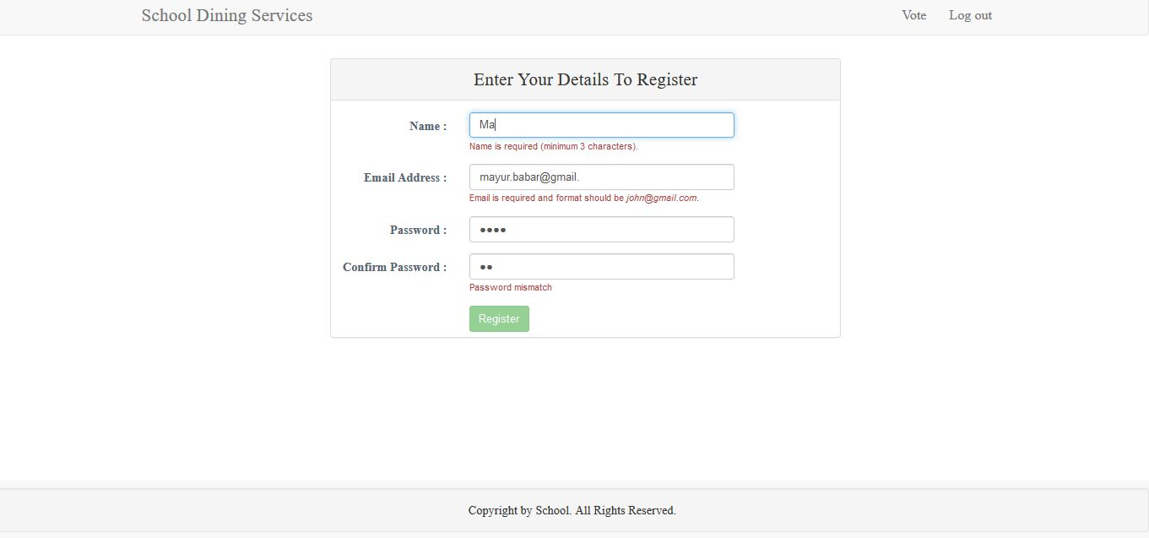

Registration Component

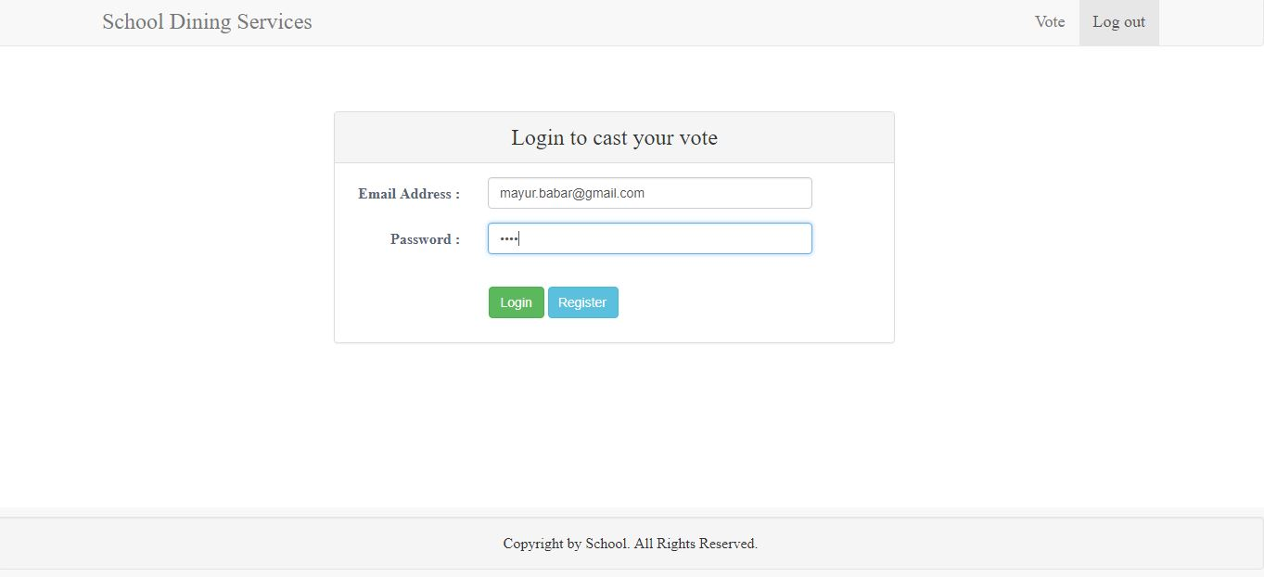

Login Component

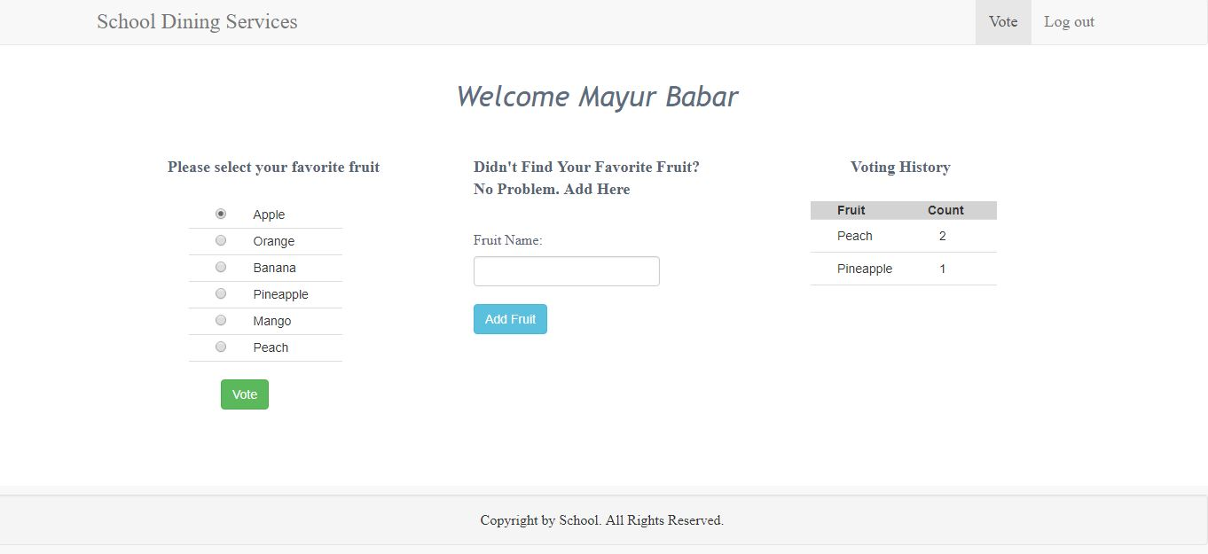

Vote Component

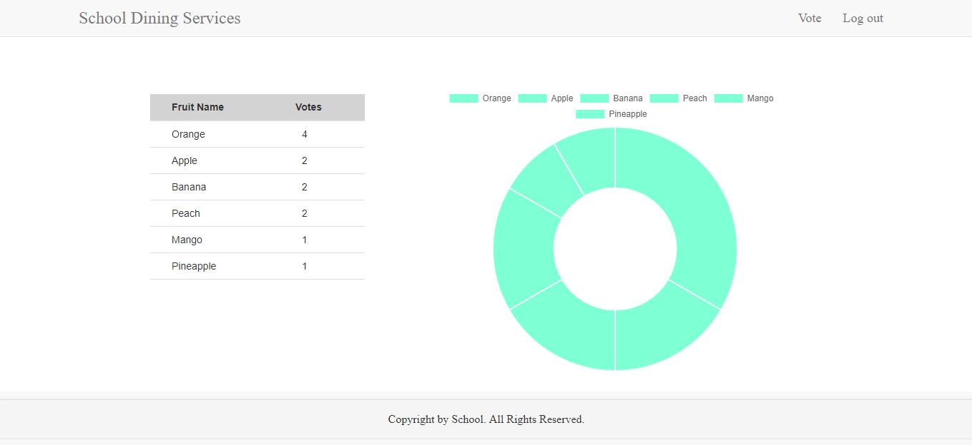

Vote Result Component